Aim: Read terminal ID using TTY command to know which terminal we are working.

# Learning Outcome: Able to work Linux environment by using Linux commands.

Duration: 1 Hour.

List of Hardware/Software requirements:

1. Computer Desktop/Laptop
2. Linux Operating System

# Code/Program/Procedure (with comment):

* tty

## tty

There is a command called tty that displays terminal-related information.

Output:

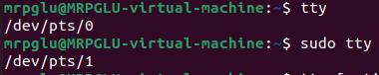

## tty --help

Display this help and exit.

Output:

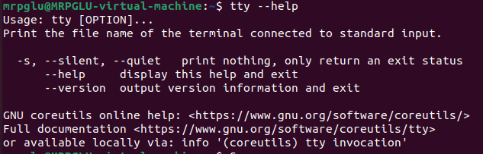

## tty --version

Output version information and exit.

Output:

